**ASSIGNMENTS ON DIGITAL MARKETING**

**NAME: K.S.SRINIVASAN**

**DEPARTMENT:** BE ELECTRONICS AND COMMUNICATION ENGINEERING

**COLLEGE:** 8151 DHANALAKSHMI SRINIVASAN INSTITUTE OF

TECHNOLOGY

**NAANMUDHALVAN COURSE**: DIGITAL MARKETING

**NM ID:** 152E400859533569880413A60E61D7FC

**ASSIGNMENT 1:**

Create a blog or website using Blogspot and WordPress. Customize

The theme design and post new article with 500 words.

<https://wordpress.com/posts/dmkneetacademy.wordpress.com>

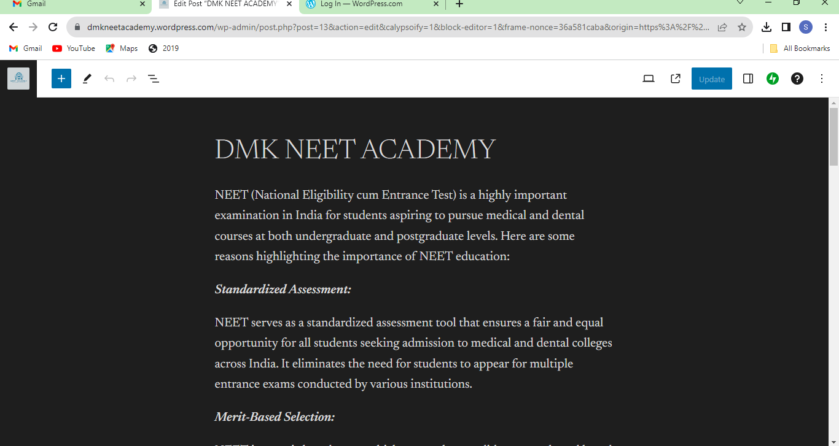

**ASSIGNMENT 2:**

Create a new Facebook business Page and Post one social media poster for your brand.

<https://www.facebook.com/profile.php?id=61550402651238&mibextid=ZbWKwL>

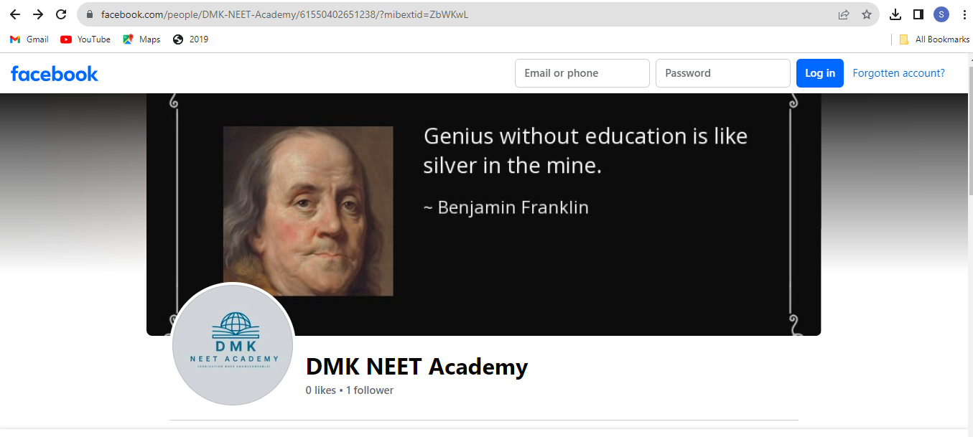

**ASSIGNMENT 3:**

Create and design a social media advertisement poster using Canva.

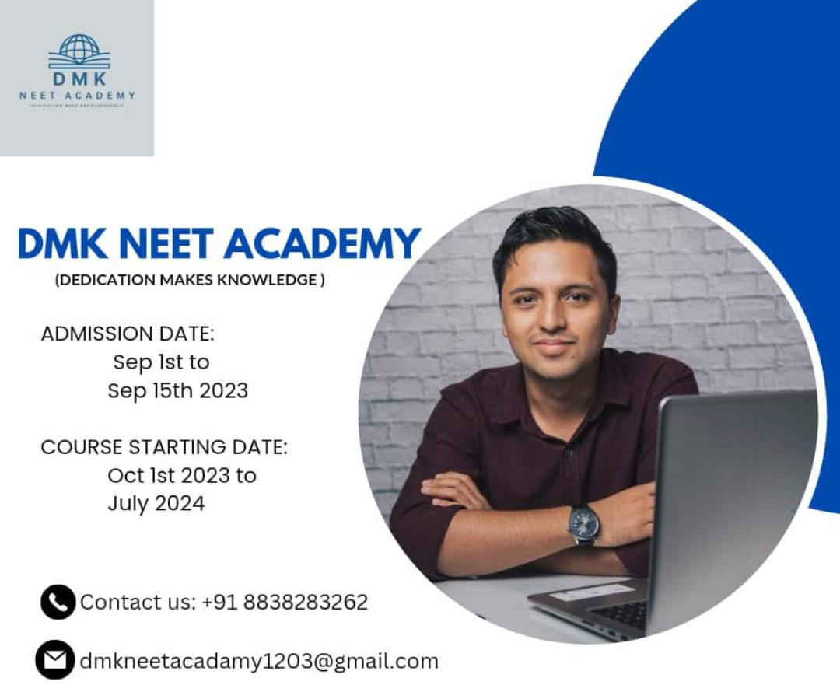

**ASSIGNMENT 4:**

Create email newsletter design using MailChimp or Canva tool.

